МІНІСТЕРСТВО ОСВІТИ І НАУКИ УКРАЇНИ
Національний аерокосмічний університет ім. М.Є. Жуковського
“Харківський авіаційний інститут”

Кафедра комп’ютерних систем, мереж і кібербезпеки (503)

Лабораторна робота № 5

з дисципліни “WEB-програмування”

Изучение возможностей
языка серверных сценариев–PHP. Ознакомление с функциями навигации по файловой системе.

ХАІ.503.535Б.19О. 050102, 1705047

Виконав студент гр. 535Б Климов В.С.
(№ групи) (П.І.Б.)

(підпис, дата)
Перевірив доцент каф. 503
(науковий ступінь, вчене звання, посада)
Морозова О.І.
(підпис, дата) (П.І.Б.)

2019

Задание на лабораторную работу №5

Цель:
Изучение возможностей языка серверных сценариев – PHP. Ознакомление с функциями навигации по файловой системе.

Постановка задачи:
Необходимо в сайт, созданный в лабораторной работе №4 добавить страницу Файловый навигатор. Данная страница должна представлять собой окно, позволяющее выполнять навигацию по файловой системе сервера в рамках каталога, где размещается сайт. Файловый менеджер должен выводить следующую информацию о файле на сервере:
- Имя файла
- Тип (файл или каталог)
- Размер файла (в единицах KB, MB, GB в зависимости от размера файла)
- Дата создания файла
- Функция согласно варианту задания

Инструментальные средства:
В качестве языка программирования серверных сценариев обязательно должен быть использован язык PHP.

Для формирования кода могут быть использованы следующие программные пакеты
- Блокнот (Notepad.exe)
- PHP Expert Editor
- Home Site
- И любые другие аналогичные пакеты

Вариант задания №3
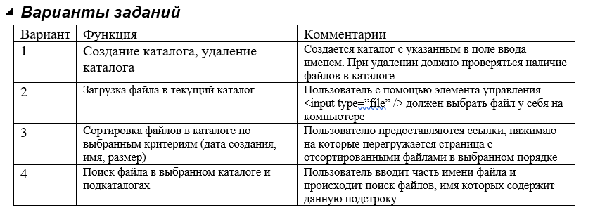

Варианты заданий
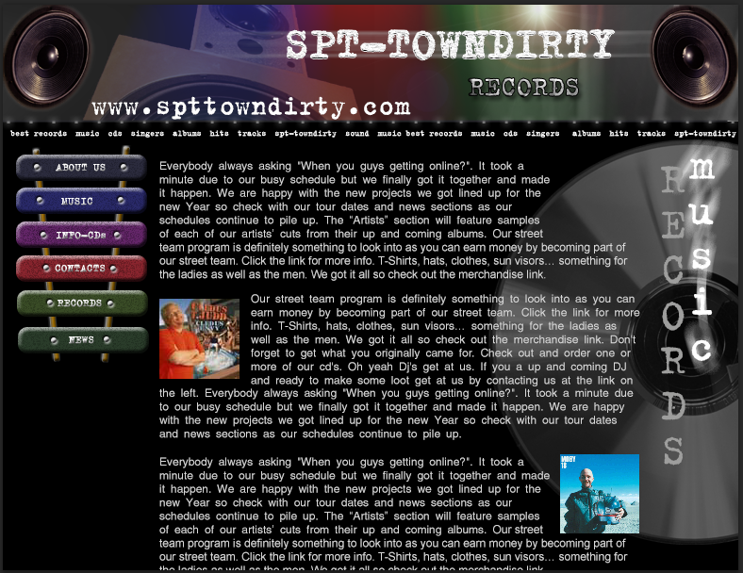

Рис. 1 - картинка гипертекстовой страницы, которая соответствует этому варианту 7

Часть 2. HTML и CSS файлы для решения задачи

Файл - index.html

<!DOCTYPE html>
<html>
<head>
<meta charset="utf-8" />
<title>Климов В.С.</title>
<script type="text/javascript" src="scripts/animation.js"></script>
<script type="text/javascript" src="scripts/script.js"></script>
<link rel="stylesheet" href="styles/style.css" />
</head>
<body onload="return animate();">
<div id="canvas">
<header>
<!--<img src="" alt="Header" />-->
<div id="headRef"><a href="index.html">www.spttowndirty.com</a></div>
</header>
<main>
<!--<span id="underheaderline" class="textColor hText">best records music cds singers albums hits tracks spt-towndirty sound music best records music cds singers albums hits tracks spt-towndirty</span>-->
<div id="menu" class="hText">
<ul>
<li>best records</li>
<li>music</li>
<li>cds</li>
<li>singers</li>
<li>albums</li>
<li>hits</li>
<li>tracks</li>
<li>spt-towndirty</li>
<li>sound</li>
</ul>
</div>
<div class="wrap-content">
<div class="col1">
<ul id="list">
<li><a href="index.html">about us</a></li>
<li><a href="redirect.html">music</a></li>
<li><a href="form.html">info-cds</a></li>
<li><a href="">contacts</a></li>
<li><a href="">records</a></li>
<li><a href="">news</a></li>
</ul>
</div>
<div class="col2">
<div>
<div class="text textColor">
<img class="content-img-r" src="images/img1.jpg" alt="img1">
Everybody always asking "When you guys getting online?". It took a
minute due to our busy schedule but we finally got it together and made
it happen. We are happy with the new projects we got lined up for the
new Year so check with our tour dates and news sections as our
schedules continue to pile up. The “Artists” section will feature samples
of each of our artists’ cuts from their up and coming albums. Our street
team program is definitely something to look into as you can earn money by becoming part of
our street team. Click the link for more info. T-Shirts, hats, clothes, sun visors… something for
the ladies as well as the men. We got it all so check out the merchandise link.
</div>
<div class="text textColor">
<img class="content-img-l" src="images/img2.jpg" alt="img2">
Our street team program is definitely something to look into as you can
earn money by becoming part of our street team. Click the link for more
info. T-Shirts, hats, clothes, sun visors… something for the ladies as
well as the men. We got it all so check out the merchandise link. Don't
forget to get what you originally came for. Check out and order one or
more of our cd's. Oh yeah Dj's get at us. If you a up and coming DJ
and ready to make some loot get at us by contacting us at the link on
the left. Everybody always asking "When you guys getting online?". It took a minute due
to our busy schedule but we finally got it together and made it happen. We are happy
with the new projects we got lined up for the new Year so check with our tour dates
and news sections as our schedules continue to pile up.
</div>
<div class="text textColor">
<img class="content-img-r" src="images/img3.jpg" alt="img3">
Everybody always asking "When you guys getting online?". It took a
minute due to our busy schedule but we finally got it together and made
it happen. We are happy with the new projects we got lined up for the
new Year so check with our tour dates and news sections as our
schedules continue to pile up. The “Artists” section will feature samples
of each of our artists’ cuts from their up and coming albums. Our street
team program is definitely something to look into as you can earn money by becoming part of
our street team. Click the link for more info. T-Shirts, hats, clothes, sun visors… something for
the ladies as well as the men. We got it all so check out the merchandise link.
</div>
</div>
</div>
<div id="animated"></div>
<div id="animated1"></div>
</div>
</main>
</div>
</body>
</html>

Файл – form.html
<!DOCTYPE html>
<html>
<head>
<meta charset="utf-8" />
<title>Климов В.С.</title>
<script type="text/javascript" src="scripts/animation.js"></script>
<script type="text/javascript" src="scripts/script.js"></script>
<link rel="stylesheet" href="styles/style.css" />
</head>
<body onload="return animate();">
<div id="canvas">
<header>
<!--<img src="" alt="Header" />-->
<a href="index.html"><div id="headRef">www.spttowndirty.com</div></a>
</header>
<main>
<!--<span id="underheaderline" class="textColor hText">best records music cds singers albums hits tracks spt-towndirty sound music best records music cds singers albums hits tracks spt-towndirty</span>-->
<div id="menu" class="hText">
<ul>
<li>best records</li>
<li>music</li>
<li>cds</li>
<li>singers</li>
<li>albums</li>
<li>hits</li>
<li>tracks</li>
<li>spt-towndirty</li>
<li>sound</li>
</ul>
</div>
<div class="wrap-content">
<div class="col1">
<ul id="list">
<li><a href="index.html">about us</a></li>
<li><a href="redirect.html">music</a></li>
<li><a href="form.html">info-cds</a></li>
<li><a href="">contacts</a></li>
<li><a href="">records</a></li>
<li><a href="">news</a></li>
</ul>
</div>
<div class="col2">
<form action="index.html" onsubmit="return validateForm()">
<table>
<tr>
<td>Name:</td>
<td class="formElem"><input type="text" id="Name" oninput="validate()" placeholder="Name" /></td>
<td id="NameErr" class="err"></td>
</tr>
<tr>
<td>Surname:</td>
<td class="formElem"><input type="text" id="Surname" oninput="validate()" placeholder="Surname" /></td>
<td id="SurnameErr" class="err"></td>
</tr>
<tr>
<td>Patronymic:</td>
<td class="formElem"><input type="text" id="Patronymic" oninput="validate()" placeholder="Patronymic" /></td>
<td id="PatronymicErr" class="err"></td>
</tr>
<tr>
<td>Age:</td>
<td title="Choose your age." class="formElem clear">
<select>
<option value="1">under 16</option>
<option value="2">16-21</option>
<option value="3">21-27</option>
<option value="4">27-35</option>
<option value="5">35-45</option>
<option value="6">45-55</option>
<option value="7">above 55</option>
</select>
</td>
<td></td>
</tr>
<tr>
<td id="about">About you:</td>
<td class="formElem clear"><textarea cols="25" id="About" rows="10" placeholder="about me" oninput="validateTA()"></textarea></td>
<td id="AboutErr" class="err"></td>
</tr>
<tr>
<td></td>
<td class="formElem clear"><input id="submitButton" type="submit" value="submit" /></td>
<td></td>
</tr>
</table>
</form>
</div>
<div id="animated"></div>
<div id="animated1"></div>
</div>
</main>
</div>
</body>
</html>

Файл redirect.html
<!DOCTYPE html>
<html>
<head>
<meta charset="utf-8" />
<title>Климов В.С.</title>
<script type="text/javascript" src="scripts/animation.js"></script>
<script type="text/javascript" src="scripts/script.js"></script>
<script type="text/javascript" src="scripts/redirect.js"></script>
<link rel="stylesheet" href="styles/style.css" />
</head>
<body onload="return animate();">
<div id="canvas">
<header>
<!--<img src="" alt="Header" />-->
<a href="index.html"><div id="headRef">www.spttowndirty.com</div></a>
</header>
<main>
<!--<span id="underheaderline" class="textColor hText">best records music cds singers albums hits tracks spt-towndirty sound music best records music cds singers albums hits tracks spt-towndirty</span>-->
<div id="menu" class="hText">
<ul id="list">
<li>best records</li>
<li>music</li>
<li>cds</li>
<li>singers</li>
<li>albums</li>
<li>hits</li>
<li>tracks</li>
<li>spt-towndirty</li>
<li>sound</li>
</ul>
</div>
<div class="wrap-content">
<div class="col1">
<ul id="list">
<li><a href="index.html">about us</a></li>
<li><a href="redirect.html">music</a></li>
<li><a href="form.html">info-cds</a></li>
<li><a href="">contacts</a></li>
<li><a href="">records</a></li>
<li><a href="">news</a></li>
</ul>
</div>
<div class="col2">
<div id="redirSpan">Redirect in 3 (sec)</div>
</div>
<div id="animated"></div>
<div id="animated1"></div>
</div>
</main>
</div>
</body>
</html>

Файл – Laba_1.css

@font-face {
font-family: B52; /* ��� ������ */
src: url(../fonts/B52.woff); /* ���� � ����� �� ������� */
}
body {
margin: 0;
background-color: black;
font: normal 12px Arial;
color: white;
}
#canvas {
width: 780px;
margin: 0 auto;
}
header {
background-image: url(../images/Header.jpg);
height: 128px;
}
#headRef {
padding-left: 90px;
padding-top: 90px;
font: normal 30px B52;
}
header img {
vertical-align: bottom;
}
#underheaderline{
margin-left: 5px;
margin-bottom: 10px;
}
main {
/*height: 470px;*/
background-image: url(../images/Disk.jpg);
/*background-position: right;*/
background-position-x: right;
background-position-y: 20px;
background-repeat: no-repeat;
}
/*main:after {
content: "";
clear: both;
float: none;
display: block;
}*/
#menu ul {
margin: -5px 0 5px;
padding: 0;
text-align: center;
text-transform: uppercase;
}
.clearfix {
clear: both;
float: none;
}
#menu ul li {
display: inline-block;
padding: 5px;
text-decoration: none;
text-align: center;
list-style: none;
color: white;
}
#menu li:hover {
background-color: #990033;
color: Tomato
}
.textColor {
color: white;
}
.hText {
font: 7pt B52;
font-weight: bold;
}
#disk{
float:right;
}
.text {
font: normal 12px Arial;
line-height: 1.5;
margin-bottom: 20px;
}
.col1 {
float: left;
width: 20%;
background-image: url(../images/stics.png);
background-position: top left;
background-repeat: no-repeat;
margin: 0 1.5%;
background-size: 100% 100%;
}
#list {
list-style-type: none;
margin: 0;
padding: 7px 0px 3px 0px;
text-transform: uppercase;
}
#list a {
padding: 6px 0 7px;
margin-bottom: 8px;
}
a {
color:white;
display: block;
text-decoration: unset;
}
#list li {
/*padding: 6px 0 14px;*/
text-align: center;
}
.col2 {
float: left;
width: 65%;
}
#animated {
left: 690px;
position: absolute;
height: 400px;
width: 80px;
float: left;
background-image: url(../images/DiskText1.png);
background-repeat: no-repeat;
background-position-y: -350px;
}
#animated1 {
left: 690px;
position: absolute;
height: 400px;
width: 80px;
float: left;
background-image: url(../images/steam.png);
background-repeat: no-repeat;
background-position-y: -350px;
background-position-x: 15px;
}
.content-img-r {
float: right;
padding: 0 0 0 8px;
}
.content-img-l {
float: left;
padding: 0 8px 0 0;
}
.wrap-content {
position: relative;
font: 10pt B52;
}
.wrap-content:after {
display: block;
clear: both;
float: none;
content: "";
}
#submitButton {
width: 80px;
height: 30px;
}
.formElem {
/*height: 5%;
width:33%;
float: left;
margin: 10px;*/
font: normal 10px Arial;
}
.err:after{
clear: both;
float: none;
}
span:after {
clear: both;
float: none;
}
.err {
width: 50%;
/*float: left;
margin: 10px;*/
color: red;
font: normal 12px Arial;
}
#redirSpan {
margin: 200px 100px 200px 200px;
font-size: 16px;
}
input {
background-color: gray;
border: 2px solid #404040;
height: 25px;
width: 160px;
color: white;
border-radius: 5px;
}
textarea {
background-color: gray;
border: 2px #404040 solid;
color: white;
width: 160px;
height: 130px;
border-radius: 5px;
}
::-webkit-input-placeholder { /* Chrome/Opera/Safari */
color: #ff6a00;
}
select {
background-color: gray;
height: 31px;
width: 100px;
border: 2px solid #404040;
color: white;
border-radius: 5px;
}
.clear {
content: "";
display: block;
float:none;
clear:both;
}
td {
padding-top:10px;
}
#about {
vertical-align:top;
}
table {
margin-bottom: 60px;
width: 100%;
}

Файл animation.js
; function animate(duration) {
var element = document.getElementById("animated");
var fps = 60;
var x1 = -350;
var x2 = 0;
//var positionY = 0;//-350;
var duration = 3000.0;
//var k = 1 / duration;
var t0 = new Date();//skolko
var intervalID = setInterval(frame, 1000.0 / fps);
function frame() {
var elp = new Date();//10
var delta = elp.getTime() - t0.getTime();
var k = delta / duration;
var coord;
if (k > 1) {
k = 1;
coord = func(k);
element.style.backgroundPositionY = coord + "px";
clearInterval(intervalID);
animate1(1);
}
else {
coord = func(k);
element.style.backgroundPositionY= coord + "px";
}
};
; function func(k) {
return x = x1 + (x2 - x1) * (Math.sqrt(k));
}
};
; function animate1(duration) {
var element = document.getElementById("animated1");
var fps = 60;
var x1 = -400;
var x2 = 0;
//var positionY = 0;//-350;
var t = 1500.0;
//var k = 1 / duration;
var t0 = new Date();
var intervalID = setInterval(frame, 1000.0 / fps);
function frame() {
var elp = new Date();
var delta = elp.getTime() - t0.getTime();
var k = delta / t;
var coord;
if (k > 1) {
k = 1;
coord = func(k);
element.style.backgroundPositionY = coord + "px";
clearInterval(intervalID);
}
else {
coord = func(k);
element.style.backgroundPositionY = coord + "px";
}
};
; function func(k) {
return x = x1 + (x2 - x1) * (Math.sqrt(k));
}
};

redirect.js
document.onload = red();
;function red(){
var clock = 3;
var t1 = setInterval(function () {
var text = document.getElementById("redirSpan");
clock--;
if (clock == -1) {
clearInterval(t1);
location.href = "index.html";
}
else {
text.innerHTML = "Redirect in " + clock + " (sec)";
}
}, 1000);
}

script.js
; function validateForm() {
var Name = document.getElementById("Name");
var Surname = document.getElementById("Surname");
var Patronymic = document.getElementById("Patronymic");
var NameErr = document.getElementById("NameErr");
var SurnameErr = document.getElementById("SurnameErr");
var PatronymicErr = document.getElementById("PatronymicErr");
var About = document.getElementById("About");
var AboutErr = document.getElementById("AboutErr");
// var
var text = Name.value;
var validMessage = "*Only A-Z, a-z symbols allow."
//sreturn false;
var validName = validateString(text);
if (!validName) {
NameErr.textContent = validMessage;
} else {
NameErr.textContent = null;
}
text = Surname.value;
var validSurn = validateString(text);
if (!validSurn) {
valid2 = false;
SurnameErr.textContent = validMessage;
} else {
SurnameErr.textContent = null;
}
text = Patronymic.value;
var validPart = validateString(text);
if (!validPart) {
PatronymicErr.textContent = validMessage;
} else {
PatronymicErr.textContent = null;
}
text = About.value;
var validTextAr = validateTextarea(text)
if (!validTextAr) {
AboutErr.textContent = validMessage;
} else {
AboutErr.textContent = null;
}
return validName && validSurn && validPart && validTextAr;
}
; function validate() {
//alert('asd');
var text = event.target.value;
var target = event.target;
//alert(text);
if (text == "" || text == null) {
event.target.style.border = "2px solid grey";
}
else {
var isValid = true;
var textLen = text.length;
text = text.trim();
if (!text.match(/^[a-z\s]+$/i)) {
isValid = false;
}
if (isValid) {
target.style.border = "2px solid green";
} else {
target.style.border = "2px solid red";
}
}
}
; function validateString(string) {
var reg = /^[a-z\s]+$/i;
string = string.trim();
return reg.test(string);
};
; function validateTextarea(string) {
var reg = /^[A-Za-z\d\s\.,]+$/;
string = string.trim();
return reg.test(string);
}
; function validateTA() {
//alert('asd');
var text = event.target.value;
var target = event.target;
//alert(text);
if (text == "" || text == null) {
event.target.style.border = "2px solid grey";
}
else {
var isValid = true;
var textLen = text.length;
text = text.trim();
if (!text.match(/^([A-Za-z\d\s\.,]+)$/)) {
isValid = false;
}
if (isValid) {
target.style.border = "2px solid green";
} else {
target.style.border = "2px solid red";
}
}
}

footer.php
</div>
<div id="animated"></div>
<div id="animated1"></div>
</div>
</main>
</div>
</body>
</html>

Form.php
<?php require('header.php');?>
<div id ="div_text">
<div class ="text_main">
<form action="server_info.php" method="post" onsubmit="return validateForm()">
<div>
<div id="sur_div">Surname:</div>
<div class="form_input"><input type="text" name="surname" placeholder="Surname" id="surname"/></div>
<div id="error_surname"></div>
</div>
<div class="form_clear">
<div><br>Name:</div>
<div class="form_input"><input type="text" name="Name" placeholder="Name" id="Name" /></div>
<div id="error_Name"></div>
</div>
<div class="form_clear">
<div><br>Patron:</div>
<div class="form_input"><input type="text" name="Patronymic" placeholder="Patron" id="Patronymic" /></div>
<div id="error_Patronymic"></div>
</div>
<div class="form_clear">
<div><br>Your old:</div>
<div><select name="select" placeholder="select" id="select">
<option value="1">Below 16</option>
<option value="2">16-21</option>
<option value="3">21-27</option>
<option value="4">27-35</option>
<option value="5">35-45</option>
<option value="6">45-55</option>
<option value="7">Under 55</option>
</select></div>
</div>
<div><br><input type="submit" name="submit" value="submit" /></div>
</form>
</div>
</div>
<?php require('footer.php');?>

header.php

<!DOCTYPE html>
<html>
<head>
<meta charset="utf-8" />
<title>Климов В.С.</title>
<script type="text/javascript" src="scripts/animation.js"></script>
<!-- <script type="text/javascript" src="scripts/script.js"></script>-->
<link rel="stylesheet" href="styles/style.css" />
</head>
<body onload="return animate();">
<div id="canvas">
<header>
<!--<img src="" alt="Header" />-->
<div id="headRef"><a href="index.html">www.spttowndirty.com</a></div>
</header>
<main>
<!--<span id="underheaderline" class="textColor hText">best records music cds singers albums hits tracks spt-towndirty sound music best records music cds singers albums hits tracks spt-towndirty</span>-->
<div id="menu" class="hText">
<ul>
<li>best records</li>
<li>music</li>
<li>cds</li>
<li>singers</li>
<li>albums</li>
<li>hits</li>
<li>tracks</li>
<li>spt-towndirty</li>
<li>sound</li>
</ul>
</div>
<div class="wrap-content">
<div class="col1">
<ul id="list">
<li><a href="index.php">about us</a></li>
<li><a href="redirect.php">music</a></li>
<li><a href="Form.php">info-cds</a></li>
<li><a href="server_info.php">contacts</a></li>
<li><a href="file_system.php">records</a></li>
<li><a href="">news</a></li>
</ul>
</div>
<div class="col2">

index.php
<?php require('header.php');?>
<div>
<div class="text textColor">
<img class="content-img-r" src="images/img1.jpg" alt="img1">
Everybody always asking "When you guys getting online?". It took a
minute due to our busy schedule but we finally got it together and made
it happen. We are happy with the new projects we got lined up for the
new Year so check with our tour dates and news sections as our
schedules continue to pile up. The “Artists” section will feature samples
of each of our artists’ cuts from their up and coming albums. Our street
team program is definitely something to look into as you can earn money by becoming part of
our street team. Click the link for more info. T-Shirts, hats, clothes, sun visors… something for
the ladies as well as the men. We got it all so check out the merchandise link.
</div>
<div class="text textColor">
<img class="content-img-l" src="images/img2.jpg" alt="img2">
Our street team program is definitely something to look into as you can
earn money by becoming part of our street team. Click the link for more
info. T-Shirts, hats, clothes, sun visors… something for the ladies as
well as the men. We got it all so check out the merchandise link. Don't
forget to get what you originally came for. Check out and order one or
more of our cd's. Oh yeah Dj's get at us. If you a up and coming DJ
and ready to make some loot get at us by contacting us at the link on
the left. Everybody always asking "When you guys getting online?". It took a minute due
to our busy schedule but we finally got it together and made it happen. We are happy
with the new projects we got lined up for the new Year so check with our tour dates
and news sections as our schedules continue to pile up.
</div>
<div class="text textColor">
<img class="content-img-r" src="images/img3.jpg" alt="img3">
Everybody always asking "When you guys getting online?". It took a
minute due to our busy schedule but we finally got it together and made
it happen. We are happy with the new projects we got lined up for the
new Year so check with our tour dates and news sections as our
schedules continue to pile up. The “Artists” section will feature samples
of each of our artists’ cuts from their up and coming albums. Our street
team program is definitely something to look into as you can earn money by becoming part of
our street team. Click the link for more info. T-Shirts, hats, clothes, sun visors… something for
the ladies as well as the men. We got it all so check out the merchandise link.
</div>
</div>
<?php require('footer.php');?>

redirect.php
<?php require('header.php');?>
<script type="text/javascript" src="scripts/redirect.js"></script>
<div id="redirSpan">Redirect in 3 (sec)</div>
<?php require('footer.php');?>

server_info.php

<?php require('header.php');?>
<?php require('server_vars.php');?>
<?php require('footer.php');?>

server_vars.php
<div style="overflow-x: scroll; width: 500px;">
<div>
<p style="color: green">$_SERVER</p>
<?php
foreach($_SERVER as $key=>$var){
echo "<p>$key = $var<P>";
echo "<hr/>";
}
echo "<br/>";
echo "<hr/>";
?>
</div>
<div >
<p style="color: green">$_GET</p>
<?php
foreach($_GET as $key=>$var){
echo "<p>$key = $var<P>";
echo "<hr/>";
}
echo "<br/>";
echo "<hr/>";
?>
</div>
<div >
<p style="color: green">$_POST</p>
<?php
foreach($_POST as $key=>$var){
echo "<p>$key = $var<P>";
echo "<hr/>";
}
echo "<br/>";
echo "<hr/>";
?>
</div>
</div>

validate.php
<?php require_once('header.php')?>
<main class="content">
<form action="index.php" onsubmit="return validateForm()">
<table>
<tr>
<td>Name:</td>
<td class="formElem"><input type="text" id="Name" oninput="validate()" placeholder="Name" /></td>
<td id="NameErr" class="err"></td>
</tr>
<tr>
<td>Surname:</td>
<td class="formElem"><input type="text" id="Surname" oninput="validate()" placeholder="Surname" /></td>
<td id="SurnameErr" class="err"></td>
</tr>
<tr>
<td>Patronymic:</td>
<td class="formElem"><input type="text" id="Patronymic" oninput="validate()" placeholder="Patronymic" /></td>
<td id="PatronymicErr" class="err"></td>
</tr>
<tr>
<td>Age:</td>
<td title="Choose your age." class="formElem clear">
<select>
<option value="1">under 16</option>
<option value="2">16-21</option>
<option value="3">21-27</option>
<option value="4">27-35</option>
<option value="5">35-45</option>
<option value="6">45-55</option>
<option value="7">above 55</option>
</select>
</td>
<td></td>
</tr>
<tr>
<td id="about">About you:</td>
<td class="formElem clear"><textarea cols="25" id="About" rows="10" placeholder="about me" oninput="validateTA()"></textarea></td>
<td id="AboutErr" class="err"></td>
</tr>
<tr>
<td></td>
<td class="formElem clear"><input id="submitButton" type="submit" value="submit" /></td>
<td></td>
</tr>
</table>
</form>
</main>
<?php require_once('footer.php')?>

file_system.php
<?php
require('header.php');
// Get all files from current directory or use path from GET
function get_dir_files() {
$dir_path = __DIR__;
$skip_back = true;
if (!empty($_GET['path']) && file_exists($_GET['path']) && strpos($_GET['path'], __DIR__) !== false && strpos($_GET['path'], '/..') === false) {
if ($_GET['path'] != __DIR__) {
$dir_path = $_GET['path'];
$skip_back = false;
}
}
$dir_files = scandir($dir_path);
$files = [];
foreach ($dir_files as $file) {
if ($file == '.' || ($skip_back && $file == '..')) continue;
$path = $dir_path . '/' . $file;
$info = get_info($path, $file);
$files[] = [
'name' => $info['name'],
'path' => $info['path'],
'type' => $info['type'],
'size' => $info['size'],
'date' => $info['date'],
];
}
sort_files($files);
return $files;
}
// Generate file info
function get_info($path, $filename) {
$type = 'directory';
$size = '-';
$name = $filename;
$dir_path = '';
if (is_dir($path)) {
$dir_path = '<a href="?path='. realpath($path) .'">'. $filename .'</a>';
} else {
$type = 'file';
$size = filesize($path);
}
return [
'name' => $name,
'path' => $dir_path,
'type' => $type,
'size' => $size,
'date' => filemtime($path),
];
}
// Get correct file size name
function file_size_convert($bytes)
{
$bytes = floatval($bytes);
$arBytes = array(
0 => array(
"UNIT" => "TB",
"VALUE" => pow(1024, 4)
),
1 => array(
"UNIT" => "GB",
"VALUE" => pow(1024, 3)
),
2 => array(
"UNIT" => "MB",
"VALUE" => pow(1024, 2)
),
3 => array(
"UNIT" => "KB",
"VALUE" => 1024
),
4 => array(
"UNIT" => "B",
"VALUE" => 1
),
);
foreach($arBytes as $arItem)
{
if($bytes >= $arItem["VALUE"])
{
$result = $bytes / $arItem["VALUE"];
$result = str_replace(".", "," , strval(round($result, 2)))." ".$arItem["UNIT"];
break;
}
}
return $result;
}
// Sorting function
function sort_files(&$files) {
if (empty($_GET['sort'])) return;
$sort_type = !empty($_GET['sort_type']) ? $_GET['sort_type'] : 'asc';
foreach ($_GET['sort'] as $sort) {
usort($files, function ($a, $b) use ($sort, $sort_type) {
if ($sort == 'name') {
if ($sort_type == 'desc') {
return - strcasecmp($a[$sort], $b[$sort]);
}
return strcasecmp($a[$sort], $b[$sort]);
}
if ($a[$sort] == $b[$sort]) {
return 0;
}
if ($sort_type == 'desc') {
return ($a[$sort] > $b[$sort]) ? -1 : 1;
}
return ($a[$sort] < $b[$sort]) ? -1 : 1;
});
}
}
// Created HTML for files result
function print_files() {
$files = get_dir_files();
if (empty($files)) {
echo 'There are no files in this directory';
return;
}
$html = '<table>
<tr>
<th>Имя</th>
<th>Тип</th>
<th>Размер</th>
<th>Дата создания</th>
</tr>';
foreach ($files as $file) {
$html .= '<tr>
<td>'. ($file["path"] ?: $file["name"]) .'</td>
<td>'. $file["type"] .'</td>
<td>'. file_size_convert($file["size"]) .'</td>
<td>'. date('d-m-Y H:s:i', $file["date"]) .'</td>
</tr>';
}
$html .= '</table>';
return $html;
}
// Created GET query for sorting
function buildSortQuery($type) {
$data = $_GET;
if (!empty($data['sort']) && in_array($type, $data['sort'])) {
unset($data['sort'][array_search($type, $data['sort'])]);
} else {
$data['sort'][] = $type;
}
return http_build_query($data);
}
// Created GET query for sorting type
function buildSortTypeQuery($type) {
$data = $_GET;
if (!empty($data['sort_type'])) {
unset($data['sort_type']);
}
$data['sort_type'] = $type;
return http_build_query($data);
}
?>
<div class="sorting">
<a href="?<?= buildSortQuery('date'); ?>" <?= (isset($_GET['sort']) && in_array('date', $_GET['sort'])) ? 'style="color:green;"' : ''; ?>>дата создания</a>
<a href="?<?= buildSortQuery('name'); ?>" <?= (isset($_GET['sort']) && in_array('name', $_GET['sort'])) ? 'style="color:green;"' : ''; ?>>имя</a>
<a href="?<?= buildSortQuery('size'); ?>" <?= (isset($_GET['sort']) && in_array('size', $_GET['sort'])) ? 'style="color:green;"' : ''; ?>>размер</a>
<a href="?<?= buildSortTypeQuery('asc'); ?>" <?= (!isset($_GET['sort_type']) || $_GET['sort_type'] == 'asc') ? 'style="color:green;"' : ''; ?>>ASC</a>
<a href="?<?= buildSortTypeQuery('desc'); ?>" <?= (isset($_GET['sort_type']) && $_GET['sort_type'] =='desc') ? 'style="color:green;"' : ''; ?>>DESC</a>
</div>
<div class="file-table">
<?= print_files(); ?>
</div>
<? require('footer.php'); ?>

Часть 3. Картинка полученного результата
Полученная гипертекстовая страница с использованием языка HTML, а также таблиц стилей CSS продемонстрированная на рис. 2

Рис. 2
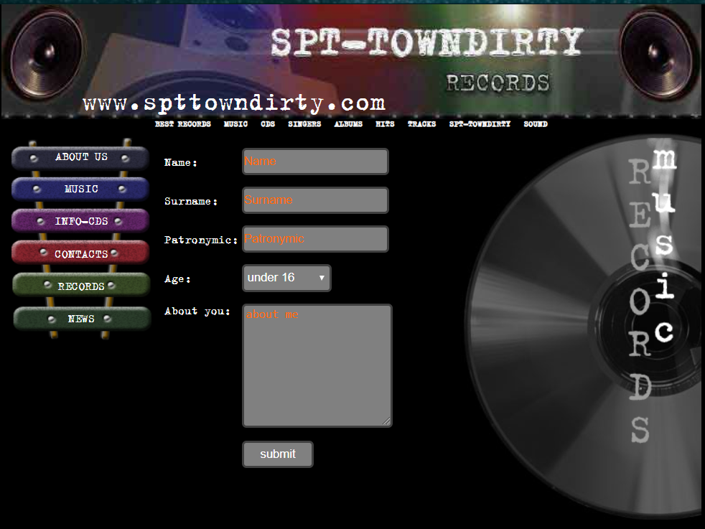
Рис 3

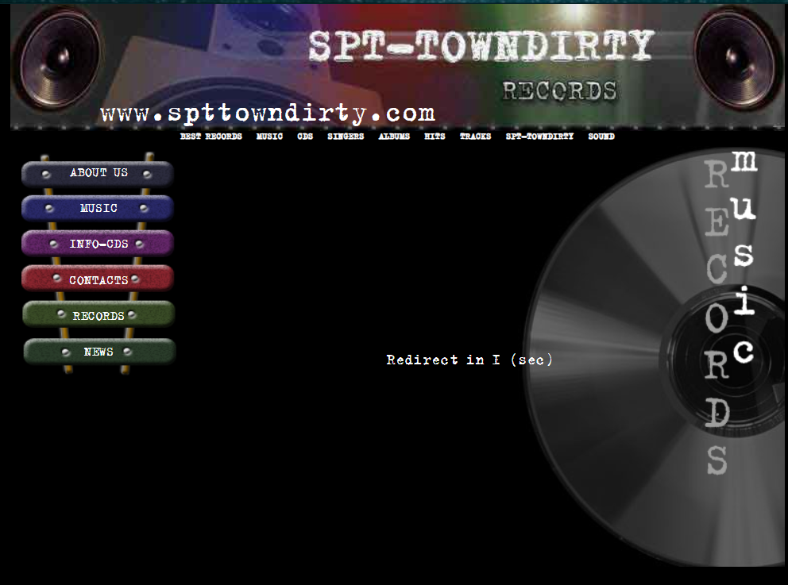
Рис 4
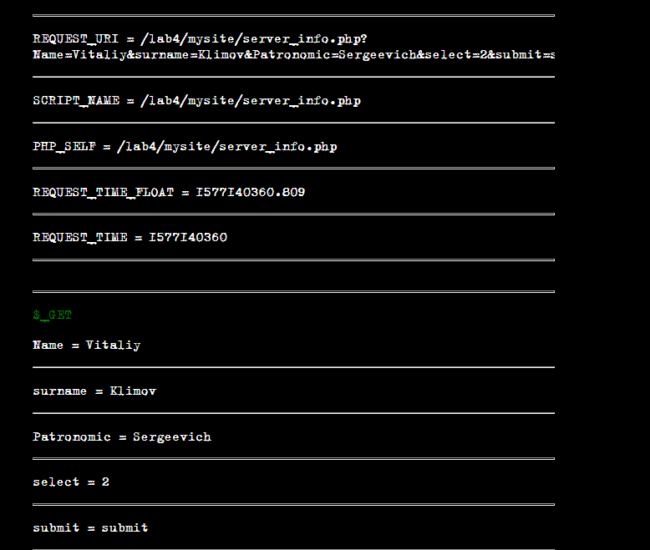
Рис 5

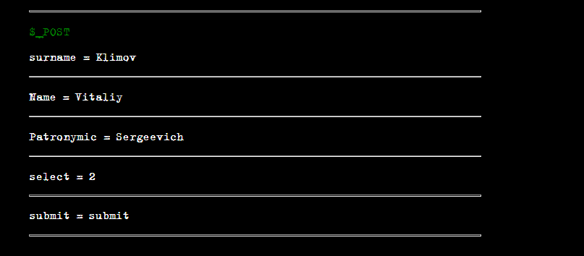

Рис6

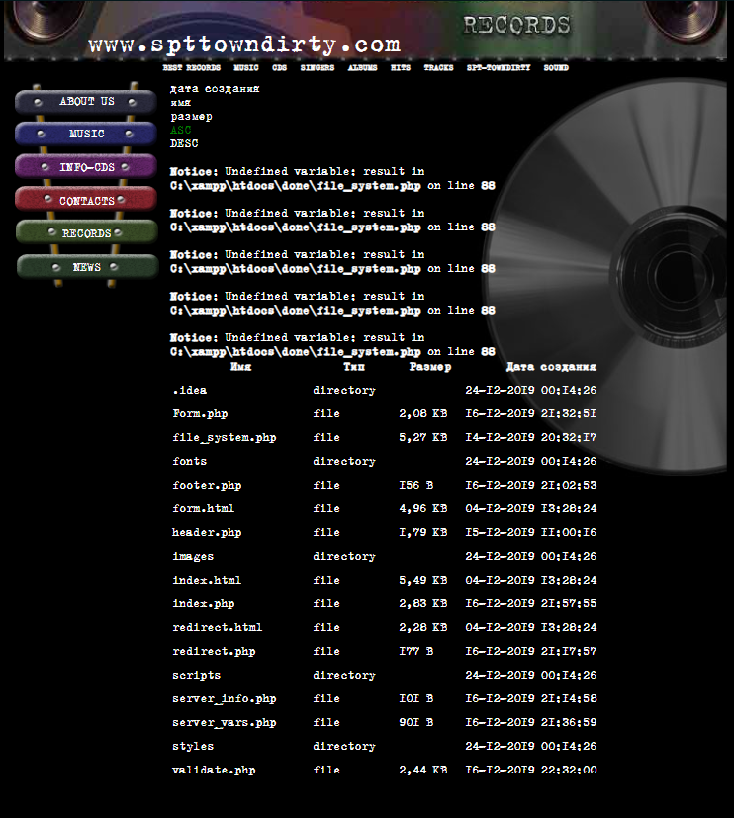
Рис7

Выводы
В результате выполнения лабораторной работы была разработана гипертекстовая страница с использованием языка HTML, а также таблиц стилей CSS. Научился использовать глобальные и локальные включения, работать с основными тегами и свойствами а также писать java-скрипты.
Также изучил возможности языка серверных сценариев – PHP. Ознакомился с функциями навигации по файловой системе.

